Year 6 Production – Music Link
Please see below for the attached YouTube link for the music for our production.
https://www.youtube.com/watch?v=mtEW-0aZjs8&list=PLGuxhVoVa7iAUTBOr4VYWQHMq1eyfQiGO
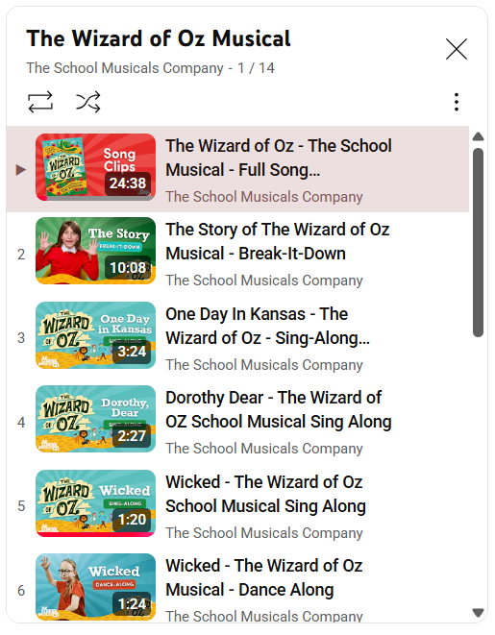
The link should take you to a playlist which has the full music, as well as sing-along versions of each song.

If you are struggling to access this, please search the below in the YouTube search bar:
