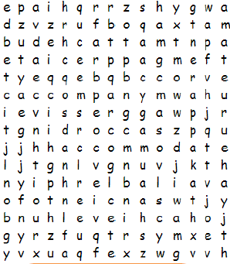 Create Your Own Word Search
Make a word search in your Learning Log that has all of this half-term’s statutory spellings in it.
Last week, we discussed how it is important to not just copy a spelling each time: Look, Say, Cover, Write, Check! You need to explain to an adult why you need to practise spellings this way.
So when you are creating your wordsearch, do it without just copying the spelling words – memorise them first and check them. We will need to be using these spellings in our writing!
Writing Homework 19.11.’18 | Due in 26.11.’18

Create Your Own Word Search
Make a word search in your Learning Log that has all of this half-term’s statutory spellings in it.
Last week, we discussed how it is important to not just copy a spelling each time: Look, Say, Cover, Write, Check! You need to explain to an adult why you need to practise spellings this way.
So when you are creating your wordsearch, do it without just copying the spelling words – memorise them first and check them. We will need to be using these spellings in our writing!

