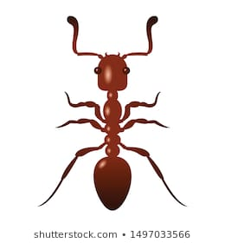
Factor Bugs
Please explain to your parents what a factor bug is – you’ll need to show them quite a few examples of different numbers so they can see how the factor bug might change depending on the number.
Some good numbers to use would be:
- 24
- 16
- 17
As you’re showing your parents, make sure you’re using the correct mathematical vocabulary in your explanation:

Reflection
Am I confident with using and understanding the vocabulary?
Which do I need to practise more or ask my teacher about?

- Factor
- Factor pair
- Multiple
- Prime number
- Square number

Maths Homework 8.11.19 | Due in 15.11.’19

Factor Bugs
Please explain to your parents what a factor bug is – you’ll need to show them quite a few examples of different numbers so they can see how the factor bug might change depending on the number.
Some good numbers to use would be:
- 24
- 16
- 17
As you’re showing your parents, make sure you’re using the correct mathematical vocabulary in your explanation:

Reflection
Am I confident with using and understanding the vocabulary?
Which do I need to practise more or ask my teacher about?

- Factor
- Factor pair
- Multiple
- Prime number
- Square number

