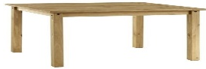
Regular Homework Table
You need to create a table to record the daily practice you are doing of reading, spelling and maths.
Your table must include:
- Reading – which book and pages you have read and any interesting words you’ve found.
- Spelling – which words you’ve practised and the way you used to do it, e.g. bubble writing.
- Maths – which KIRFs you’ve done and which specific facts, e.g. decimal number bonds to 1: 0.3 + 0.7 =1 , 1 - 0.8 = 0.2
This task is to help keep us in the habit of doing this continual, regular homework; however it is also about making you think about how to organise a lot of information, which is a skill you need in lots of different circumstances.
Don’t worry if you start it one way and it doesn’t work; learn from that and try it a different way – I often have to do that when I’m making things for us to use in class.
One more rule: you’re not allowed to ask your parents for help until you’ve tried at least three different ways of doing it, then you can.
Feel free to make it as pretty or decorative as you like, as long as the information is still clearly presented.
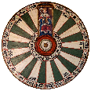
Challenege: these are differen tables – what are they?

