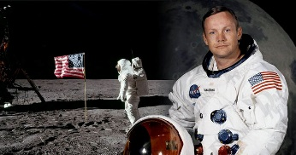 The Life of Neil Armstrong
Over the next few weeks, we are going to be developing a biography, (the story of someone’s life). To help you when writing, you need to find out as many facts as you can about Neil Armstrong’s life.
You need to think, talk and make notes about:
- His early life, i.e. his childhood, school, friendships, experiences.
- What made him first become interested in being an astronaut?
- What were the important dates in his life?
- What was he like as a person - why?
- Any other life-changing or important events.
Remember, the more thought you put in now, the easier and more enjoyable the writing is!
Writing Homework 4.11.21 | Due in 11.11.21

The Life of Neil Armstrong
Over the next few weeks, we are going to be developing a biography, (the story of someone’s life). To help you when writing, you need to find out as many facts as you can about Neil Armstrong’s life.
You need to think, talk and make notes about:
- His early life, i.e. his childhood, school, friendships, experiences.
- What made him first become interested in being an astronaut?
- What were the important dates in his life?
- What was he like as a person - why?
- Any other life-changing or important events.
Remember, the more thought you put in now, the easier and more enjoyable the writing is!

