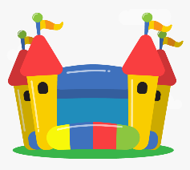
You’re old enough to buy your own house…
Find the house prices for 3 houses around Otley, then 3 houses in Greece. See how many you can find that are in the millions! Put the 6 house prices in number order, then rewrite them, rounding them to the nearest million, then the nearest hundred thousand.
It is up to you how you present your work, but it must fit on one page in your books.
Fine print: you are not really old enough to buy your own house and if you do become that rich you have to buy Mr Fisk a swimming pool made out of Lego and filled with melted chocolate (it’s the law).

Maths Homework 30.9.’21 | Due in 7.10.’21

You’re old enough to buy your own house…
Find the house prices for 3 houses around Otley, then 3 houses in Greece. See how many you can find that are in the millions! Put the 6 house prices in number order, then rewrite them, rounding them to the nearest million, then the nearest hundred thousand.
It is up to you how you present your work, but it must fit on one page in your books.
Fine print: you are not really old enough to buy your own house and if you do become that rich you have to buy Mr Fisk a swimming pool made out of Lego and filled with melted chocolate (it’s the law).

