English Homework 5.5.22 | Due in 12.5.22
What is a Pronoun?
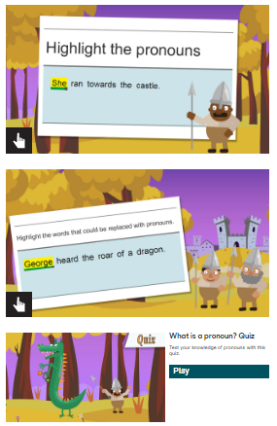
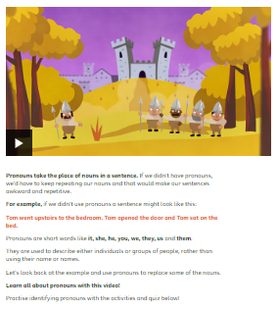
Go to: https://www.bbc.co.uk/
bitesize/topics/zwwp8mn/
articles/z37xrwx
You’ll find a short clip, a little bit of reading and three short activities to do.
After you’ve done those, I want you to write a list of pronouns in your homework book – how many can you find (stop at 40)?

English Homework 5.5.22 | Due in 12.5.22
What is a Pronoun?
Go to: https://www.bbc.co.uk/
bitesize/topics/zwwp8mn/
articles/z37xrwx
You’ll find a short clip, a little bit of reading and three short activities to do.
After you’ve done those, I want you to write a list of pronouns in your homework book – how many can you find (stop at 40)?

English Homework 5.5.22 | Due in 12.5.22
What is a Pronoun?
Go to: https://www.bbc.co.uk/
bitesize/topics/zwwp8mn/
articles/z37xrwx
You’ll find a short clip, a little bit of reading and three short activities to do.
After you’ve done those, I want you to write a list of pronouns in your homework book – how many can you find (stop at 40)?

