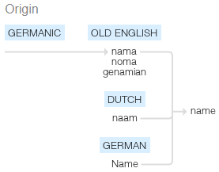
Me & My Name
Almost all names have a meaning. The origins of our first names and surnames can be very old and have come from many different places.
You need to be an etymologist and find out which language, people and geographical area your names came from: first, middle and surnames! If there is a quick answer to your name, e.g. Johnson means ‘son of John’, find out what ‘John’ means and where it’s from.
Are there any links to other words you know? Think about everything we’ve done in class on etymology and morphology.
If, like me, you don’t have a middle name, feel free to pick one and research that (I think I’d make a good Francesca).

Writing Homework 14.10.19 | Due in 21.10.19

Me & My Name
Almost all names have a meaning. The origins of our first names and surnames can be very old and have come from many different places.
You need to be an etymologist and find out which language, people and geographical area your names came from: first, middle and surnames! If there is a quick answer to your name, e.g. Johnson means ‘son of John’, find out what ‘John’ means and where it’s from.
Are there any links to other words you know? Think about everything we’ve done in class on etymology and morphology.
If, like me, you don’t have a middle name, feel free to pick one and research that (I think I’d make a good Francesca).

