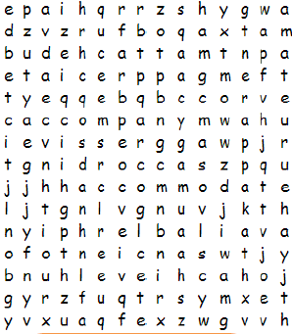 Create Your Own Word Search
Make a word search in your Learning Log that uses twenty of the statutory spellings in it.
We’ve discussed how it is important to not just copy a spelling each time: Look, Say, Cover, Write, Check! You need to explain to an adult why you need to practise spellings this way.
So when you are creating your wordsearch, do it without just copying the spelling words – memorise them first and check them. We will need to be using these spellings in our writing!

Writing Homework 21.10.19 | Due in Friday 8.11.19

Create Your Own Word Search
Make a word search in your Learning Log that uses twenty of the statutory spellings in it.
We’ve discussed how it is important to not just copy a spelling each time: Look, Say, Cover, Write, Check! You need to explain to an adult why you need to practise spellings this way.
So when you are creating your wordsearch, do it without just copying the spelling words – memorise them first and check them. We will need to be using these spellings in our writing!

